A Project Report

on

***HOME AUTOMATION USING ARDUINO & WI-FI***

*Submitted for the partial fulfillment of the requirement for the award of the Degree of*

***Bachelor Of Technology***

In

***Computer Science & Engineering***

by

**Sameer Dudeja (160102172)**

**Akul Aggarwal (160102175)**

**Mohit Shrivastava (160102185)**

Under the Guidance of

**Mrs. Madhu Sharma**

Assistant Professor

Computer Science & Engineering

DIT University, Dehradun



**DIT UNIVERSITY, DEHRADUN, INDIA**

April’201

A Project Report

on

***HOME AUTOMATION USING ARDUINO & WI-FI***

*Submitted for the partial fulfillment of the requirement for the award of the Degree of*

***Bachelor Of Technology***

In

***Computer Science & Engineering***

by

**Sameer Dudeja (160102172)**

**Akul Aggarwal (160102175)**

**Mohit Shrivastava (160102185)**

Under the Guidance of

**Mrs. Madhu Sharma**

Assistant Professor

Computer Science & Engineering

DIT University, Dehradun



**DIT UNIVERSITY, DEHRADUN, INDIA**

April’2019



**DECLARATION**

This is to certify that the Project entitled **“Home Automation using Arduino & Wi-fi”** in partial fulfillment of the requirement for the award of the **Degree of Bachelor of Technology** in **Computer Science & Engineering**, submitted to **DIT University, Dehradun, Uttarakhand, India,** is an authentic record of bona fide work carried out by us, under the guidance of **Mrs. Madhu Sharma.**

The matter embodied in this Project/Thesis/Dissertation has not been submitted for the award of any other degree or diploma to any University/Institution.

|  |  |  |
| --- | --- | --- |
|  |  |  |
| Sameer Dudeja  Mohit Shrivastava  Akul Agarwal |  | Mrs. Madhu Sharma  Assistant Professor,  Computer Science & Engineering,  DIT University,Dehradun |
|  |  |  |
|  |  |  |
|  |  |  |
| **Dr. Vishal Bharti**  **Head of Department**  **Signature** |  |  |

***Date:29/04/2019***

***Place: Dehradun***

iii



**CERTIFICATE**

This is to certify that the Project entitled **“Home Automation using Arduino & Wi-fi”** in partial fulfillment of the requirement for the award of the **Degree Bachelor of Technology** in **Computer Science & Engineering** ,submitted to **DIT University, Dehradun, Uttarakhand, India,** is an authentic record of bona fide research work carried out by **Mr. Sameer Dudeja** (160102172) ,under my supervision/guidance.

**Mrs. Madhu Sharma**

Assistant Professor

Computer Science & Engineering

DIT University, Dehradun

***Date:29/04/2019***

***Place: Dehradun***

iv



**CERTIFICATE**

This is to certify that the Project entitled **“Home Automation using Arduino & Wi-fi”** in partial fulfillment of the requirement for the award of the **Degree Bachelor of Technology** in **Computer Science & Engineering** ,submitted to **DIT University, Dehradun, Uttarakhand, India,** is an authentic record of bona fide research work carried out by **Mr. Mohit Shrivastava**(160102185),under my supervision/guidance.

**Mrs. Madhu Sharma**

Assistant Professor

Computer Science & Engineering

DIT University, Dehradun

***Date:29/04/2019***

***Place: Dehradun***

v



**CERTIFICATE**

This is to certify that the Project entitled **“Home Automation using Arduino & Wi-fi”** in partial fulfillment of the requirement for the award of the **Degree Bachelor of Technology** in **Computer Science & Engineering** ,submitted to **DIT University, Dehradun, Uttarakhand, India,** is an authentic record of bona fide research work carried out by **Mr. Akul Aggarwal** (160102175) ,under my supervision/guidance.

**Mrs. Madhu Sharma**

Assistant Professor

Computer Science & Engineering

DIT University, Dehradun

***Date:29/04/2019***

***Place: Dehradun***

vi

**ACKNOWLEDGEMENT**

We take this opportunity to express our profound gratitude and deep regards to everyone who has helped us in completing this project.  We have taken efforts in this project. However, it would not have been possible without the kind support and help of many individuals and organizations and we would like to extend our sincere thanks to all of them.

We are highly indebted to Mrs. Madhu Sharma for her guidance and constant supervision as well as for providing necessary information regarding the project & also for her support in completing the project. We are wholeheartedly thankful to her for giving us her valuable time, attention and for providing us a systematic way for completing our project in time.

We must make special thanks to our H.O.D. Dr. Vishal Bharti and DIT University for giving us this opportunity and platform to show case or skills in our various fields of interests.

Lastly, we thank our parents and friends for their constant encouragement in developing the project and people who have willingly helped us out with their abilities.

vii

**ABSTRACT**

This project presents a design and prototype implementation of new home automation system that uses Wi-Fi technology as a network infrastructure connecting its parts. The proposed system consists of two main components; the first part is the server (web server), which presents system core that manages, controls, and monitors users’ home.

Users and system administrator can locally (LAN) or remotely (internet) manage and control system code. Second part is hardware interface module, which provides appropriate interface to sensors and actuator of home automation system.

Unlike most of available home automation system in the market the proposed system is scalable that one server can manage many hardware interface modules 5 as long as it exists on Wi-Fi network coverage. System supports a wide range of home automation devices like power management components, and security components.

The proposed system is better from the scalability and flexibility point of view than the commercially available home automation systems.

viii

**TABLE OF CONTENTS**

**Title Page No.**

DECLARATION...................................................................................iii

CERTIFICATE………...……………………………………………...iv-vi

ACKNOWLEDGEMENT…………………………………………….vii

ABSTRACT……………………………………………………..…....viii

TABLE OF CONTENTS……………………………………..…….....ix-x

LIST OF FIGURES................................................................................xi

ABBREVIATIONS……………………………………………………xii

**CHAPTER 1INTRODUCTION**

1.1 Purpose ...............................................................................................1

1.2 Objective ............................................................................................1-2

1.3 Motivation……………………….……………………………..……2

1.4 Definition and Overview………………………………………….....2-3

**CHAPTER 2 OVERALL DESCRIPTION**

2.1 Project Perspective ..............................................................................4

2.2 Project Functions…….……….............................................................5-6

2.3 Diagrams………………………………………………………………7-8

2.3.1 Circuit Diagrams ……………………………………………….7-8

2.3.2 Use Case .………………………………………………….........9

2.4 Constraints and Assumptions…............................................................9

**CHAPTER3 EXTERNAL INTERFACE REQUIREMENTS**

3.1 User Interfaces…………………………………………………………10

3.2 Hardware Interfaces……………………………………………............10-12

3.3 Software Interfaces……………………………………………….........13

3.4 Communications Interfaces…………………………………….……...13

**CHAPTER4SYSTEM FEATURES**

4.1 Code Snippet……………………………………………………….........14-15

x

4.2 Output…………………………………………………………………….115-16

**CHAPTER 5OTHER NONFUNCTIONAL REQUIREMENTS**

5.1 Performance Requirements……………………………………………….17

5.2 Safety Requirement………………………………………………….........17

5.3 Security Requirements………………………………………………........18

5.4 Software Quality Attribute…………………………………………..........18

**CHAPTER 6 CONCLUSION AND FUTURE WORK**

6.1 Conclusions ..............................................................................................19

6.2 Scope for Future Work .............................................................................19-20

BIBLIOGRAPHY …………………………………………………………...21

x

**LIST OF FIGURES**

**Figure No. Title Page No**.

2.1 Circuit Diagram…………………………………………………….…..7

2.1.1 Gas Module Circuit Diagram…………………………………………..7

2.1.2 Temperature and Water Overflow Sensor Module Circuit ……………7

2.1.3 Camera Module Circuit Diagram………………………………………8

2.1.4 Oscillograms for the Camera Module………………………………….8

2.2 Use Case………………………………………………………….........9

4.1 Code Snippet……………………………………………………….....14-15

4.2 Output…………………………………………………………………15-16

6.2 Proposed Updates Circuit Diagram…………………………………...19-20

xi

**ABBREVIATIONS**

1. GSM- Global System for Mobile Communications
2. Wi-Fi- Wireless Fidelity
3. SPI - Serial Peripheral Interface Bus
4. SPIFFS- Serial Peripheral Interface Flash File System
5. PWM- Pulse Width Modulation

**CHAPTER 1**

**INTRODUCTION**

**1.1 PURPOSE OF THE PROJECT**

**Home Automation** is a term used to describe the working together of all household amenities and appliances. The household activities are automated by the development of special appliances such as water heaters to reduce the time taken to boil water for bathing and automatic washing machines to reduce manual labour of washing clothes. In developed countries, homes are wired for electrical power, doorbell, TV outlets, and telephones. The different application includes when a person enters the room, the light turns on. In advanced technology, the room can sense the presence of the person and who the person is.

 In case of a home theatre, the home automation system can avoid distraction and lock the audio and video components and can also make an announcement. The home automation system can also dial up the house owner on their mobile phone to alert them or call any alarm monitoring company.

It is essential that the different controllable appliances be interconnected and communicate with each other. The basic aim of Home automation is to control or monitor signals from different appliances, or basic services. A smart phone or web browser can be used to control or monitor the home automation system.

**1.2 OBJECTIVE**

The improper and inefficient use of the resources given to us is just a mistake considering that the sources are fleeting away. Improper use of electricity, water etc. can and will cost us, so it’s better to preserve.

The main objective of this project is to mark a simple step towards a better future by putting better use of the resources given to us.Considering the day of the week, time of the day and other such factors it can also set appropriate lighting, temperature levels, television channels or music levels. In the case of a smoke detector when fire or smoke is detected, the lights in the entire house begin to blink to alert the resident to the probable fire.

With this project we wish to make modules that can transmit data to the user using various sensors over the internet using Wi-Fi. The user will be able to access the data on any browser connected on the same Home network.

**1.3 MOTIVATION**

The motivation to choose Home Automation is the upper hand it provides in making this project. The motivation for doing this project is primarily an interest in undertaking a challenging project in an interesting area of research. The opportunity to learn about a new area of IOT which is not covered in lectures is appealing. We have chosen this project since we were totally able to relate to the topic and were fascinated by idea of controlling various items remotely using an app/web app/or any kind of remote able to give instructions. This irregular behavior of students not only affect tem but other students and teachers as well. As this has become a major concern of modern time educational institutions it has become important to get know of the factors causing such irregularities among the students which may create negative impact. The major factor that motivated us to do this project is the possibilities it unfolds.

The fact is indisputable that, having the above introductory paragraph as a schedule, in reality, will certainly make the future homes fascinating and maybe this is just the infrastructure for a fully automated home using AI. Yet, this project needs major upgrades to be able to perform that level of computation. This project, therefore, is a small initiative by us to take one small step towards the development of fully Automated Home.

**1.4 DEFINITION AND OVERVIEW**

There are many methods currently in use to automate Homes and below are their drawbacks:

1**. Home Automation using Bluetooth:** This method usesa Bluetooth module connected to a micro-controller like Arduino or Raspberry Pi etc. for computation and transmitting of data. The main drawback would be the Range on which Bluetooth works and the limited no. of modules we can connect to the system.

2. **Home Automation using GSM:** This method uses a GSM module which would work on a Sim card and send the data using the same protocols by which we make a phone call or send a text message or access the internet. Although based on a network that uses satellites, this method is not very cost efficient, and it majorly depends on the Network Strength and may malfunction over a network congestion scenario.

3. **Home Automation using Wi-fi:** This method uses a Wi-Fi module connected to a micro – controller to send data to different data receivers over the internet. The main drawback of this method would be the range which can be increased with increased cost of the system.

**CHAPTER 2**

**OVERALL DESCRIPTION**

**2.1 PROJECT PERSPECTIVE**

The main problem better use of resources, like in saving electricity or water and/or maintaining a livable and hospitable home environment. The solution to this problem must be a complete system, as it must be implemented throughout the world for the solution to be even considered. IoT provides a perfect platform for a solution of this archetype. With all this in mind, we decided to implement a feasible and efficient IoT based solution using **Arduino** for the problem at hand. There are total 3 modules in the Home Automation System we are working on, each having their different aims and functioning.

Total no. of modules in our system are as follows:

1. Temperature and Water control Module: This module contains a DHT11 sensor and a Water Overflow sensor connected to a Node MCU which is making a web server and displaying the readings on a specific IP address which in this case is 192.168.43.117 .The circuit diagram is indicated in figure 2.1.1 and the output is indicated in fig. 4.2.1 .The code snippet is given on page 14
2. Gas Control Module: This module has a MQ2 gas sensor connected to the analog pin of the Node MCU which is also making a webserver and sending sensor data to a specific IP address which is 192.168.43.110. The circuit diagram is shown in figure 2.1.2 and the output is shown in figure 4.2.2. the code snippet is given on page 14.
3. Camera Module: This module has an OV7670 sensor connected to an Arduino Uno to click Snapshot and save it at a specific folder in the computer. This module is still a work in progress and will include a PIR sensor to trigger the camera to click a snapshot and send it to the administrator. The circuit diagram is given in figure 2.1.3 and the output on figure 4.2.3 .

**2.2 PROJECT FUNCTION**

The Node MCU modules function in the following way:

1. First the libraries are initiated i.e. ESP8266.h and DHT11
2. Then the Node MCU connects to the network using its protocols and sends data to serial port. This message also contains the IP address that it will send the data to which also contains the webpage.
3. Then a new Client is created every time the webpage is reloaded, and the values are updated. The data is also sent to the serial port at 115200 baud rates.

The camera Module functions in the following way:

The main steps in the code are as follows:

1. Setting up the Arduino Uno PWM so that it outputs 8mhz on the 11th leg.

DDRB | = (1 << 3); // pin 11   
ASSR & = ~ (\_BV (EXCLK) | \_BV (AS2));   
TCCR2A = (1 << COM2A0) | (1 << WGM21) | (1 << WGM20);   
TCCR2B = (1 << WGM22) | (1 << CS20);   
OCR2A = 0; // (F\_CPU) / (2 \* (X + 1))   
DDRC & = ~ 15; // low d0-d3 camera   
DDRD & = ~ 252; // d7-d4 and interrupt pins

2. Configure I2C Interface

TWSR & = ~ 3; // disable prescaler for TWI   
TWBR = 72; // set to 100khz

3. Setting up the RS232.

UBRR0H = 0;   
UBRR0L = 1; // 0 = 2M baud rate. 1 = 1M baud. 3 = 0.5M. 7 = 250k 207 is 9600 baud rate.   
UCSR0A | = 2; // double speed aysnc   
UCSR0B = (1 << RXEN0) | (1 << TXEN0); // Enable receiver and transmitter   
UCSR0C = 6; // async 1 stop bit 8bit char no parity bits

4. Camera setup

...   
wrReg (0x12, 0x80);   
\_delay\_ms (100);   
wrSensorRegs8\_8 (ov7670\_default\_regs);   
wrReg (REG\_COM10, 32); // PCLK does not toggle on HBLANK.   
...

5. Image Acquisition

The mode of operation of the camera image transfer was set YUV. In this case, each pixel is encoded in two bytes. The first byte encodes the grayscale, the second the color difference component.

[yuv_ov7670](http://privateblog.info/wp-content/uploads/2015/12/yuv_ov7670.gif)

Our task is to get at least black and white images, so the second byte can be dropped. Next, you should bring the waveform from which it becomes clear which signals we expect with a high and low value. The timing diagram is given in figure 2.3  8 )); // wait for high

1. **while** ((PIND &  8 )); // wait for low
3. y = hg;
4. **while** (y -) {
5. x = wg;
6. **while** (x -) {
7. // PCLK
8. **while** ((PIND &  4 )); // wait for low
9. UDR0 = (PINC &  15 ) | (PIND &  240 );
10. **while** (! (UCSR0A & ( 1  << UDRE0))); // wait for byte to transmit
11. **while** (! (PIND &  4 )); // wait for high
12. **while** ((PIND &  4 )); // wait for low
13. **while** (! (PIND &  4 )); // wait for high
14. }
15. }
16. \_delay\_ms ( 100 );

**3. A java program for capturing an image from ov7670 via Arduino Uno**

The program for obtaining images is extremely simple. It receives data from the COM2 port using the [Java Communication API](http://privateblog.info/files/javacomm20-win32.zip)  and saves it as bmp. All variables are set directly in the code.

**4. Results**

The result images are saved in .bmp files .The snapshots are given in figure 6.2.3 on page 16.

**2.3 DIAGRAMS**

**2.3.1 Circuit DIAGRAM**

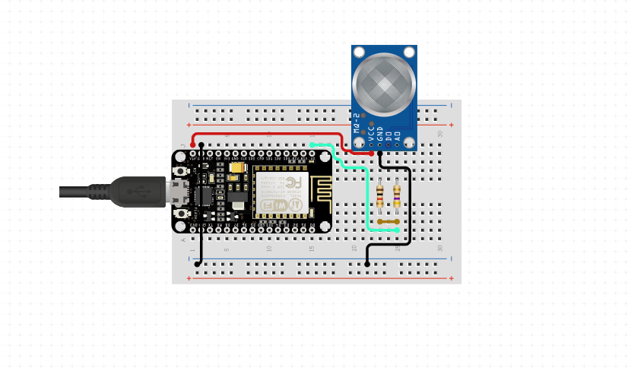

*FIG 2.1.1: Gas module Circuit diagram*

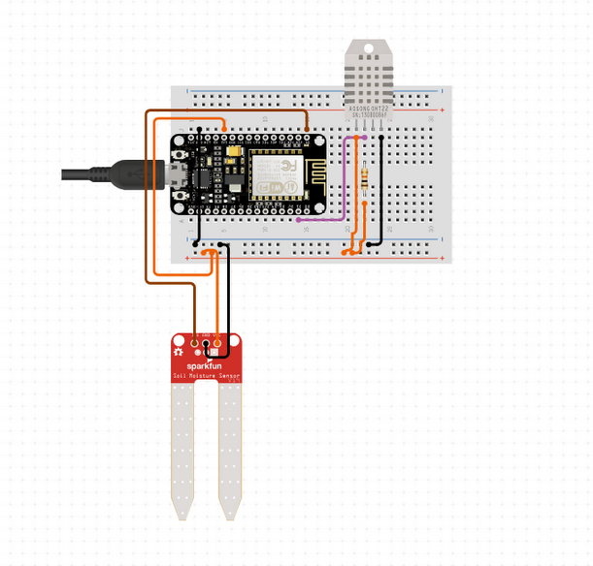

*Fig 2.1.2 Temperature and Water Overflow Circuit diagram*

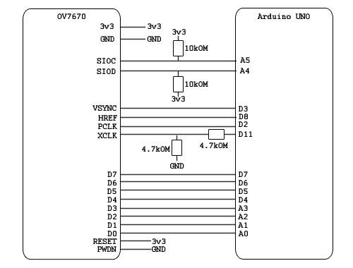

*Fig 2.1.3 Camera Module Diagram*

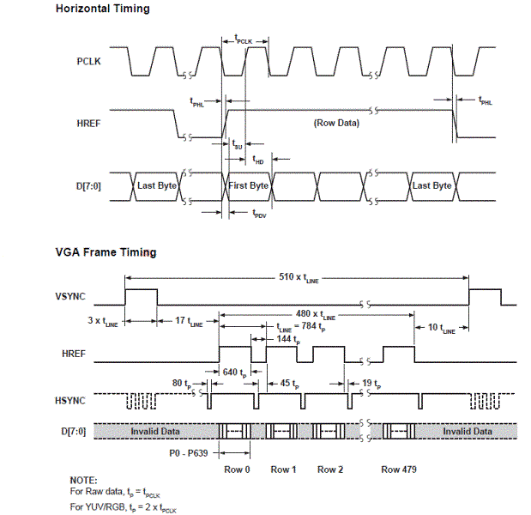

*Fig 2.1.4, Timing Diagram for Camera Module*

**2.3.2 USE CASE**

**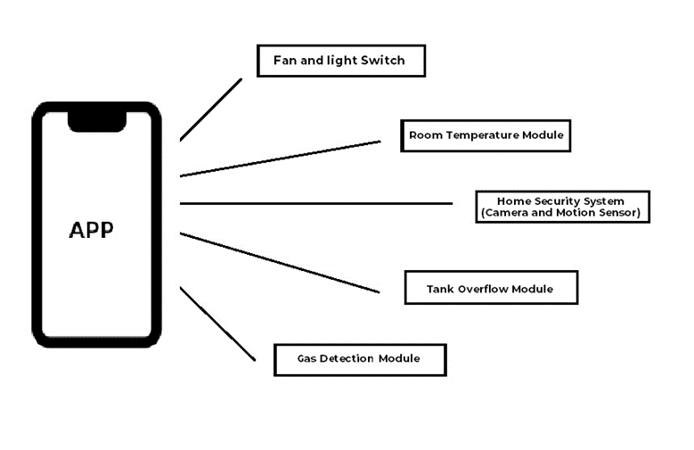**

*FIG 2.2: flow chart of proposed model*

**2.4 CONSTRAINTS**

The hardware and software constraints are as follows:

1. The Node MCU only has 1 Analog Pin i.e. A0 which is a major constraint as it only allows one Analog based sensor to be implemented on a circuit.
2. The basic pins for digital input and output are D0..D8. These also support Arduino style pin interrupts, except for D0, which cannot support PWM either.
3. If using hardware Serial Peripheral Interface Bus (SPI) to communicate with peripherals, pins D5..D8 become unavailable, as they are used for hardware SPI.

The constraints of the camera module are as follows:

1. The lack of an internal buffer leads to the blurring of the picture, since it is immediately transferred to the computer, and this takes time.

2. Artifacts in the form of horizontal stripes are observed - synchronization failure in receiving a picture. Instead of grayscale, the color difference component is sent.

3. The subject should be in focus camera for clear image.

# CHAPTER 3

# EXTERNAL INTERFACE REQUIREMENTS

# 3.1 USER INTERFACES

In user interface we define user, task, environment analysis and describe the external and internal components and the architecture of user interface with some rough pictorial views of the user interface and its components.

Here we are going to make hardware and software solutions which will help the users on daily bases efficiently using the resources they are using and increasing the living standards .The software would be a Web-app (still in development) from which the user will be easily able to upload and monitor instructions. This interface will be easy to use.

# 3.2 HARDWARE INTERFACES

For implanting the current code (i.e. of phase 1), we are doing simulations to find which kind of hardware would be the most efficient to serve the process of the module. The current system has the following hardware:

1. ARDUINO UNO: The Arduino Uno is a microcontroller board based on the ATmega328. It has 14 digital input/output pins (of which 6 can be used as PWM outputs), 6 analog inputs, a 16 MHz ceramic resonator, a USB connection, a power jack, an ICSP header, and a reset button. It contains everything needed to support the microcontroller; simply connect it to a computer with a USB cable or power it with a AC-to-DC adapter or battery to get started. The Uno differs from all preceding boards in that it does not use the FTDI USB-to-serial driver chip. Instead, it features the Atmega16U2 (Atmega8U2 up to version R2) programmed as a USB-to-serial converter. The Program will be coded in the Arduino IDE which is the default Environment used for Coding all the Arduino Devices.
2. NODE MCU: NodeMCU is an open source Lua based firmware for the ESP8266 Wi-Fi SOC from Espressif and uses an on-module flash-based SPIFFS file system. NodeMCU is implemented in C and is layered on the Espressif NON-OS SDK. The firmware was initially developed as is a companion project to the popular ESP8266-based NodeMCU development modules, but the project is now community-supported, and the firmware can now be run on any ESP module.
3. DHT11 Temperature and Humidity Sensor: DHT11 Temperature & Humidity Sensor features a temperature & humidity sensor complex with a calibrated digital signal output. By using the exclusive digital-signal-acquisition technique and temperature & humidity sensing technology, it ensures high reliability and excellent long-term stability. This sensor includes a resistive-type humidity measurement component and an NTC temperature measurement component and connects to a high performance 8-bit microcontroller, offering excellent quality, fast response, anti-interference ability and cost-effectiveness.
4. MQ2 Gas Sensor: Sensitive material of MQ-2 gas sensor is SnO2, which with lower conductivity in clean air. When the target combustible gas exists, the sensor’s conductivity is higher along with the gas concentration rising. Please use simple electro circuit, convert change of conductivity to correspond output signal of gas concentration. MQ-2 gas sensor has high sensitivity to LPG, Propane and Hydrogen, also could be used to Methane and other combustible steam, it is with low cost and suitable for different application.
5. Water / Moisture Sensor: This sensor can be used to test the moisture of soil, when the soil is having water shortage, the module output is at high level, else the output is at low level. By using this sensor one can automatically water the flower plant, or any other plants requiring automatic watering technique. Module triple output mode, digital output is simple, analog output more accurate, serial output with exact readings.
6. OV7670 Camera Sensor: The OV7670/OV7171 CAMERACHIPTM is a low voltage CMOS image sensor that provides the full functionality of a single-chip VGA camera and image processor in a small footprint package. The OV7670/OV7171 provides full-frame, sub-sampled or windowed 8-bit images in a wide range of formats, controlled through the Serial Camera Control Bus (SCCB) interface. This product has an image array capable of operating at up to 30 frames per second (fps) in VGA with complete user control over image quality, formatting and output data transfer. All required image processing functions, including exposure control, gamma, white balance, color saturation, hue control and more, are also programmable through the SCCB interface. In addition, OmniVision CAMERACHIPs use proprietary sensor technology to improve image quality by reducing or eliminating common lighting/electrical sources of image contamination, such as fixed pattern noise (FPN), smearing, blooming, etc., to produce a clean, fully stable color image.

# 3.3 SOFTWARE INTERFACES

This system uses different software interfaces which are as follows:

1. Arduino IDE: The Arduino integrated development environment (IDE) is a cross-platform application (for Windows, macOS, Linux) that is written in the programming language Java. It is used to write and upload programs to Arduino compatible boards, but also, with the help of 3rd party cores, other vendor development boards. The source code for the IDE is released under the GNU General Public License, version 2. The Arduino IDE supports the languages C and C++ using special rules of code structuring. The Arduino IDE supplies a software library from the Wiring project, which provides many common input and output procedures.

User-written code only requires two basic functions, for starting the sketch and the main program loop, that are compiled and linked with a program stub main() into an executable cyclic executive program with the GNU toolchain, also included with the IDE distribution.

# 3.4 COMMUNICATION INTERFACES

# The communication interface used here is the Wi-Fi Receiver made by NODE MCU which connects to the Internet using a Wi-Fi network and send the data to an IP Address.

The Data is also sent to Serial port of the appropriate baud rate i.e. 115200.

**CHAPTER 4**

**SYSTEM FEATURES**

**4.1 CODE SNIPPETS**

**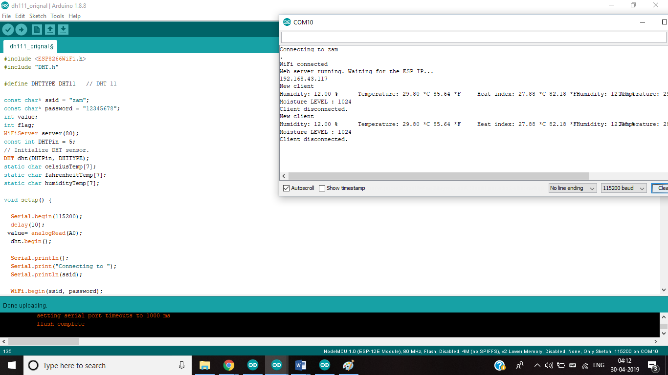**

*FIG 4.1.1: Code snippet and Serial Output for Temperature and Water Module*

*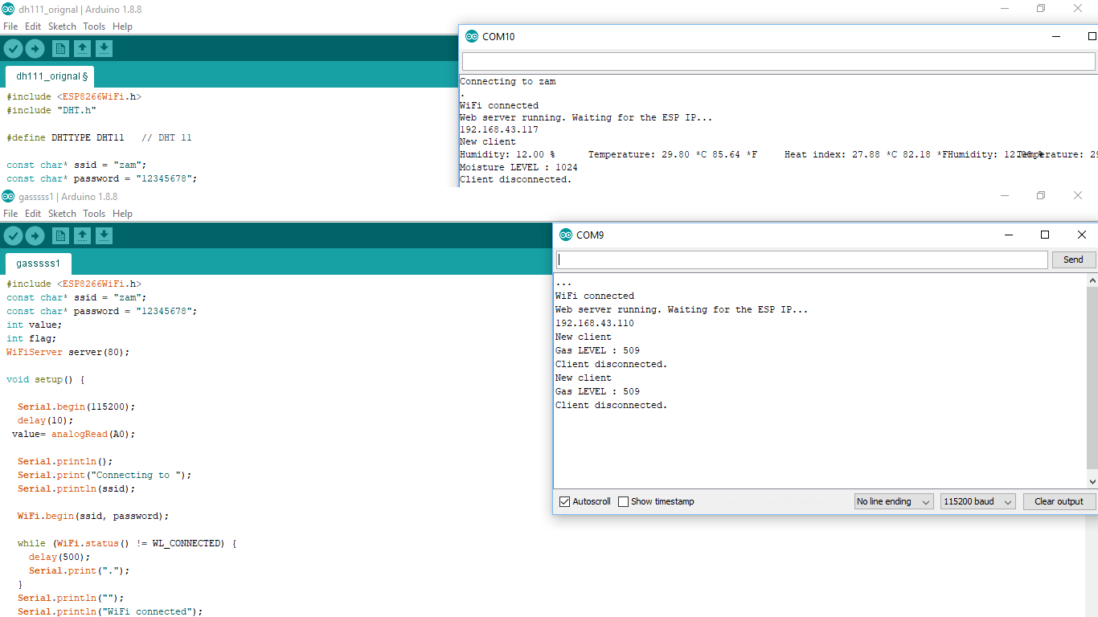*

*FIG 4.1.2: Code snippet and Serial Output for Gas Module*

**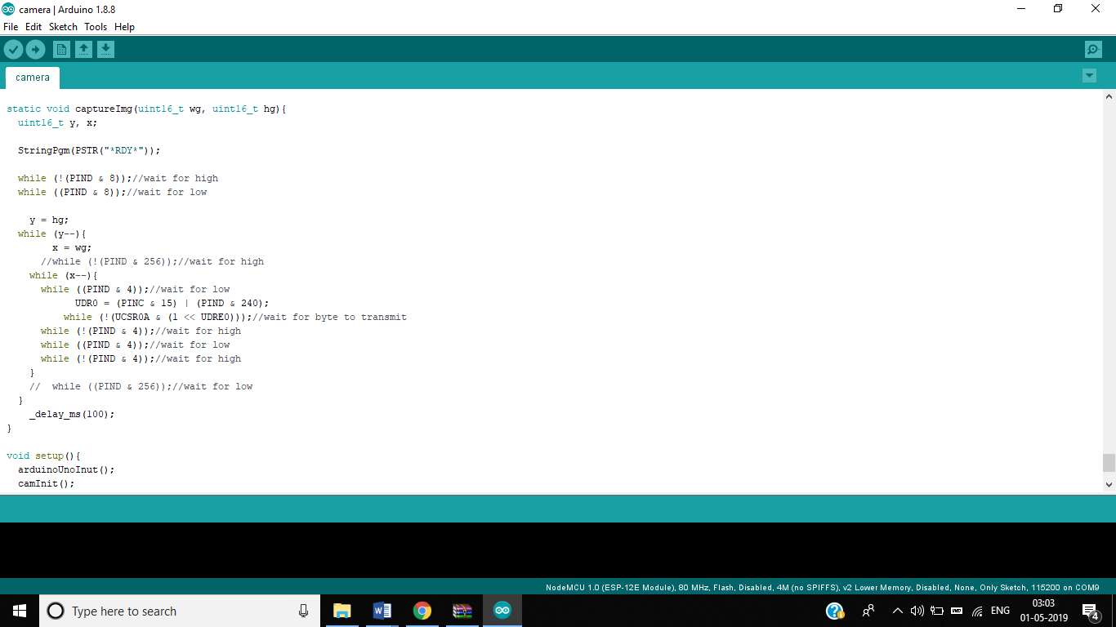**

*FIG 4.1.3: Code snippet for Camera Module*

**4.2 OUTPUT**

**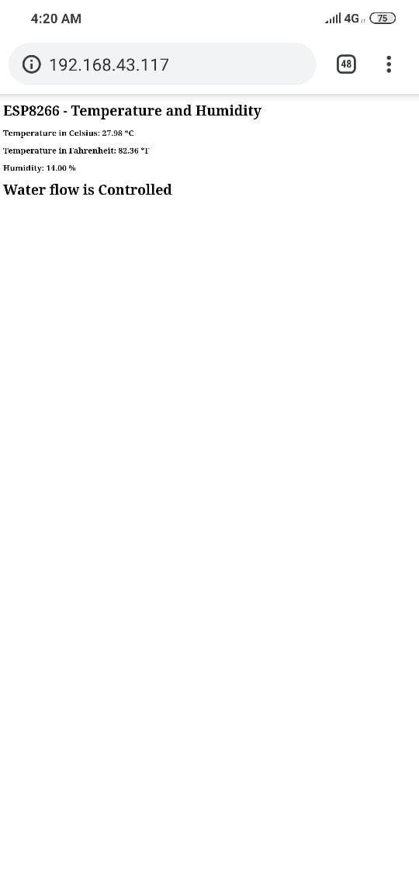**

*FIG 4.2.1: Temperature and Water Module Output*

*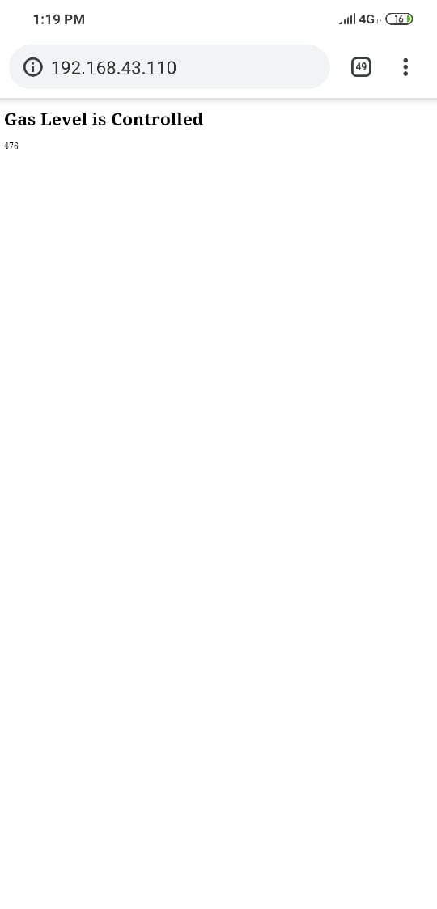*

*FIG 4.2.3: Gas Module Output*

*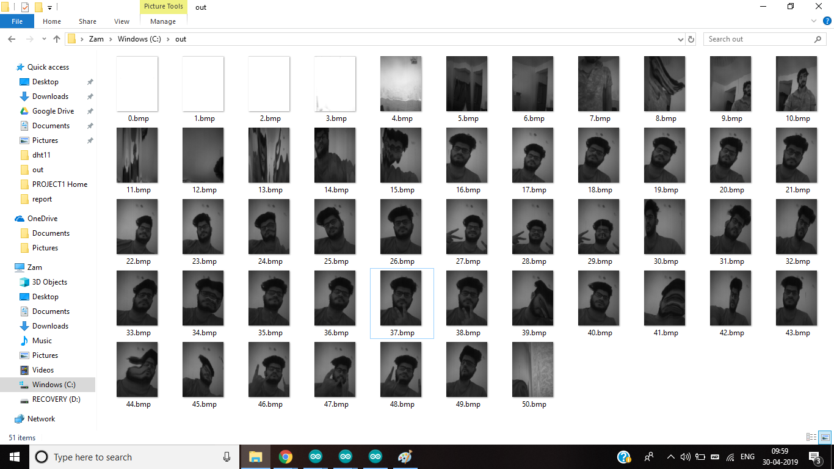*

*FIG 4.2.3: Camera Module Output*

**CHAPTER 5**

**OTHER NONFUNCTIONAL REQUIREMENTS**

**5.1 PERFORMANCE REQUIREMENTS**

We use several sensors for the detection of different values but one of these sensors depends directly on the certain values of the area it is been used i.e. MQ2 or Gas sensor. This sensor apart from other aspects requires the admin to calibrate it depending to the air quality of the area it is being installed. Apart from this , the Water/Moisture control module also requires a slight calibration depending on the placement of its nodes.

**5.2 SAFETY REQUIREMENTS**

The Internet of things (IoT) is taking the concept of safety to a whole new level. In a world where everything can be connected, and physical contact becomes optional, verbal instructions and even facial recognition are used to operate the end device, safety considerations must be made.

There are two categories of safety hazards associated with the IOT:

Type 1 hazards are directly associated with the traditional use of the device and include things such as: overheating, shock, sonic hazards, etc. Introducing IoT into products could increase the frequency of occurrence of these hazards. Enabling remote operations means that hazards of these kinds are no longer bounded by physical limitations. For instance, an electronic oven that can be turned on and off remotely can become hazardous if a faulty command is received when no one is present to watch it.

Type 2 hazards are indirectly related to the device and its operation but could enable a security or safety issue by implementing IoT. The cascade effect could be a breaching of properties or leakage of private information.

**5.3 SECURITY REQUIREMENTS**

The key requirements for any IoT security solution are:

1. Device and data security, including authentication of devices and confidentiality and integrity of data

1. Implementing and running security operations at IoT scale
2. Meeting compliance requirements and requests
3. Meeting performance requirements as per the use case

**5.4 SOFTWARE QUALITY ATTRIBUTES**

All the modules have tested code that works on almost all use cases. The code is designed to ne Reliable, maintainable, portable till some extent, efficient, secure to some extent, testable and reusable. Although all the modules are still just in testing phase, but we still try to write code that can stand up to all the basic quality attributes.

# CHAPTER 6

# CONCLUSION AND FUTURE WORK

# 6.1 CONCLUSIONS

# A system for automating human lives using IOT technology using Arduino and Wi-fi. The proposed system can prove to be utilitarian for not only home environments but also in other professional environments.

# 6.2 SCOPE FOR FUTURE WORK

There are some major updates we have planned for these modules which are as follows:

1. Camera Module Motion Detection Snapshot: The prepared Camera Module only clicks or captures a series of continuous pictures when the java code is run. We wish the module to click a snapshot whenever a PIR motion sensor detects a motion i.e. a Motion Security Camera based on Arduino which would send the images to a specific email address or web-app. The Circuit Diagram is as follows:

**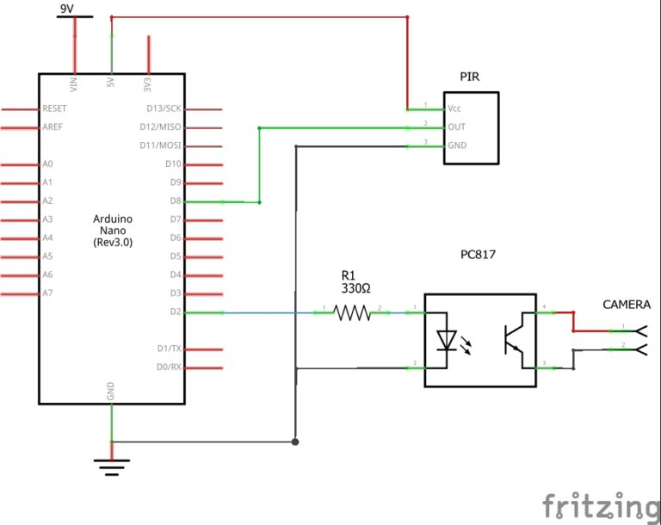**

*FIG 6.2.1: Camera Module with PIR*

1. Use of SPIFFS for Sensor Outputs:

SPIFFS which stands for SPI Flash Filing System was designed for SPI flash devices on constrained embedded microprocessor systems with little RAM. Up until now, we've always included the HTML for our web pages as string literals in our sketch. This makes our code very hard to read, and you'll run out of memory rather quickly. It's a light-weight file system for microcontrollers with an SPI flash chip. The on-board flash chip of the ESP8266 has plenty of space for your webpages, especially if you have the 1MB, 2MB or 4MB version.

Using SPIFFS, we would like to enhance the UI/UX and functionality of the webpage that displays the data right now.

We would like to test different languages but up till now we haven’t encountered a better solution than AJAX which will self-update the sensor values efficiently.

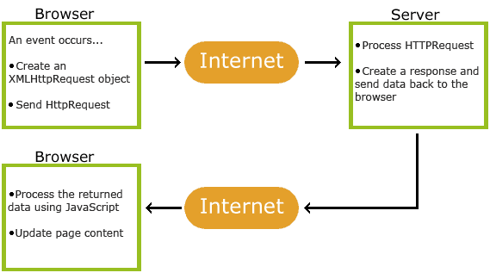

*FIG 6.2.2: Block diagram of AJAX*

**Bibliography:**

* Christian Reinisch ,“Wireless Communication in Home and Building Automation”, Master thesis, Viennia univeristy of technlogy, Feb 2007.
* N. Sriskanthan, F. Tan, A. Karande,” Bluetooth based home automation system”, Microprocessors and Microsystems journal, issue 26 (2002) pages 281–289, Elsevier Science B.V., 2002.
* Andi Adriansyah, Akhmad Wahyu Dani" Design of Small Smart Home Control Systems Based on Wireless Sensor Networks and Power Line Communications" 10.1109/TIE .2014 .2379586, IEEE Transactions on Industrial Electronics
* A.J. Bernheim Brush, Bongshin Lee, Ratul Mahajan, Sharad Agarwal, Stefan Saroiu, and Colin Dixon, "Home Automation in the Wild: Challenges and Opportunities", CHI 2011, May 7–12, 2011, Vancouver, BC, Canada
* Wikipedia (2019). *Automation*. From <http://en.wikipedia.org/wiki/Automation>.

Retrieved on 7/2/2019

* Wikipedia (2019). *Bluetooth*. From http://en.wikipedia.org/wiki/Bluetooth. Retrieved on 7/2/2019
* Wikipedia (2019). *Building Automation*. From http://en.wikipedia.org/wiki/Building\_automation. Retrieved on 7/02/2019
* Wikipedia (2019). *Ethernet*. From http://en.wikipedia.org/wiki/Ethernet. Retrieved on 8/2/2019
* Wikipedia (2019). *GSM*. From http://en.wikipedia.org/wiki/GSM. Retrieved on 8/2/2019
* Wikipedia (2019). *Home Automation*. From

http://en.wikipedia.org/wiki/Home\_automation. Retrieved on 7/2/2019